How to create been class from given JSON / MR

When we run a rest call to AppPulse Open API we expect to response in JSON format.  
We suggest to convert this response to java bean for complete the process and analyze.

There are several ways to do this conversion, here I will describe one of them.  
For this convert I used a third party (blog by Tim Boudreau, <https://timboudreau.com/blog/json/read> )

## Instructions:

* Open the URL: <https://timboudreau.com/blog/json/read> .  
  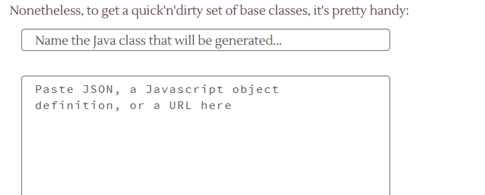
* Type the bean java class name that will be generate.
* Copy a GSON result example and paste it in the text box below.
* Remove the check from “Use Jackson annotations“.
* Click on “GO” and get the class content.